Comprehensive AI Strategy for Wagyu AE: Mapping AI Integration Across Products, Services, and Operations

Executive Summary
Wagyu AE stands at a unique intersection of luxury protein distribution and halal certification in the United Arab Emirates' premium culinary market. As the exclusive distributor of Omi Beef's halal Wagyu beef, the company has established a privileged position serving high-end restaurants, hotels, resorts, caterers, and high-net-worth individuals. This strategic analysis maps how artificial intelligence can transform the business across four dimensions of the AI Strategy Matrix: creating efficiencies, enhancing experiences, developing AI-native systems, and driving breakthrough innovations. The global Wagyu beef market is projected to reach USD 8.93 billion by 2032, growing at a CAGR of 8.6%, with the Middle East showing gradual but steady development as luxury dining gains popularity among high-income groups . Concurrently, AI technologies are reshaping food authentication and traceability, offering unprecedented opportunities to strengthen Wagyu AE's market position by ensuring halal integrity, enhancing customer experiences, and building operational excellence.

1 Step 1: Business Context Analysis
1.1 Industry Context and Market Position
Wagyu AE operates within the premium protein distribution sector, specifically focusing on the luxury segment of the global Wagyu beef market. The company functions as a specialized intermediary between Japanese Wagyu producer Omi Beef and the UAE's high-end culinary establishments and affluent consumers. The global Wagyu beef market was valued at USD 4.62 billion in 2024 and is projected to reach USD 8.93 billion by 2032, demonstrating significant growth potential in the premium meat segment . This growth is driven by several market forces particularly relevant to the UAE context:
- Growing Premium Dining Expansion: Rising numbers of high-end steakhouses, Michelin-starred restaurants, and luxury dining establishments worldwide are increasing demand for Wagyu beef as the ultimate premium protein .
- Increasing Affluence and Culinary Tourism: Growing purchasing power among affluent consumers and expanding interest in authentic culinary experiences are boosting demand for exceptional dining experiences featuring Wagyu beef .
- Middle Eastern Market Development: The Middle East and Africa region is expected to develop gradually as luxury dining and premium food imports gain popularity among high-income groups .
Wagyu AE's exclusive distribution rights for Omi Beef in the UAE create a competitive moat that can be further strengthened through AI integration. However, the company faces market challenges including high price sensitivity among potential customers, competition from domestic and Wagyu-style alternatives, and the complex regulatory and certification requirements for genuine Wagyu beef .

1.2 Core Products and Services
Wagyu AE's business centers around the exclusive distribution of authentic, halal-certified Wagyu beef from Omi Beef to the UAE market. The company's core offerings include:
- Premium Wagyu Cuts: Distribution of various grades of halal Wagyu beef, with Grade A Wagyu dominating due to its superior marbling, tenderness, and preference in premium dining experiences .
- B2B Supply to Hospitality Sector: Serving high-end restaurants, hotels, resorts, and caterers that feature Wagyu beef in their luxury menus.
- Direct-to-Consumer Services: Supplying high-net-worth individuals seeking premium Wagyu for personal consumption.
- Halal Assurance: Providing guaranteed halal compliance throughout the supply chain, a critical consideration in the UAE market.
The company's current operational model likely involves traditional supply chain management, relationship-based sales, and manual certification processes. This creates opportunities for AI-driven transformation across multiple business dimensions.

1.3 Current AI Adoption and Implementation Challenges
As a specialized distributor in a traditional industry segment, Wagyu AE is likely at an early stage of AI adoption. The company's current operations probably rely on conventional business processes with minimal integration of advanced technologies. Key challenges in scaling AI implementation include:
- High Implementation Costs: Integrating AI systems, particularly for supply chain traceability and halal authentication, requires significant investment that can strain businesses with tight margins .
- Data Infrastructure Limitations: Building the necessary data collection and management systems to support AI applications across the supply chain.
- Talent Acquisition: Attracting and retaining AI and data science expertise in a specialized food distribution context.
- Cultural and Religious Sensitivities: Navigating concerns about whether AI can fully replace human oversight in halal certification, particularly regarding spiritual intent in zabiha slaughter .
- Integration Complexity: Implementing AI solutions that work seamlessly with existing systems and business processes while accommodating the unique requirements of halal certification.
Despite these challenges, the transformative potential of AI in the halal food sector is substantial. Research indicates that AI technologies including machine learning, computer vision, natural language processing, and blockchain can significantly enhance authentication processes, supply chain transparency, and quality control in halal food production .

1.4 Relevant AI Trends and Market Shifts
Several AI trends and market developments create strategic opportunities for Wagyu AE:
- AI-Enhanced Halal Authentication: Advanced technologies are revolutionizing halal certification through blockchain-backed traceability, automated compliance checks, and real-time monitoring systems . These innovations address the critical need for transparency in halal food supply chains.
- Supply Chain Digitalization: The global Wagyu market is witnessing increased adoption of traceability technologies. For example, Japan's National Livestock Breeding Center launched a blockchain-based ID system for Wagyu cattle in March 2024, guaranteeing authenticity and enhancing export credibility .
- Personalization at Scale: AI enables hyper-personalized customer experiences even in B2B contexts, allowing for tailored recommendations and services based on individual client preferences and historical data .
- Predictive Analytics in Food Distribution: Machine learning algorithms can optimize inventory management, predict demand fluctuations, and reduce waste through more accurate forecasting.
- Computer Vision for Quality Control: AI-powered visual inspection systems can assess meat quality, marbling scores, and packaging integrity more consistently than human inspectors.
- AI-Driven Market Insights: Advanced analytics can identify emerging culinary trends, seasonal demand patterns, and competitor strategies in the premium protein market.
The convergence of these technological trends with the growing global halal food market—projected to reach $20 billion domestically in the USA by 2028 —creates a strategic imperative for Wagyu AE to embrace AI transformation to maintain and extend its competitive advantage.

2 Step 2: AI Strategy Matrix Analysis
2.1 Mapping Wagyu AE on the AI Strategy Matrix
The AI Strategy Matrix provides a framework for evaluating how Wagyu AE can integrate artificial intelligence across two dimensions: what we deliver (improving existing offerings versus creating AI-native products) and how we make it (augmenting existing operations versus building AI-native systems). Wagyu AE's current position as a traditional distributor with exclusive rights places it in the lower-left quadrant (AI Efficiencies), but strategic AI integration can propel the company across all quadrants. The following visual representation maps the company's current and potential AI initiatives across the four strategic options:
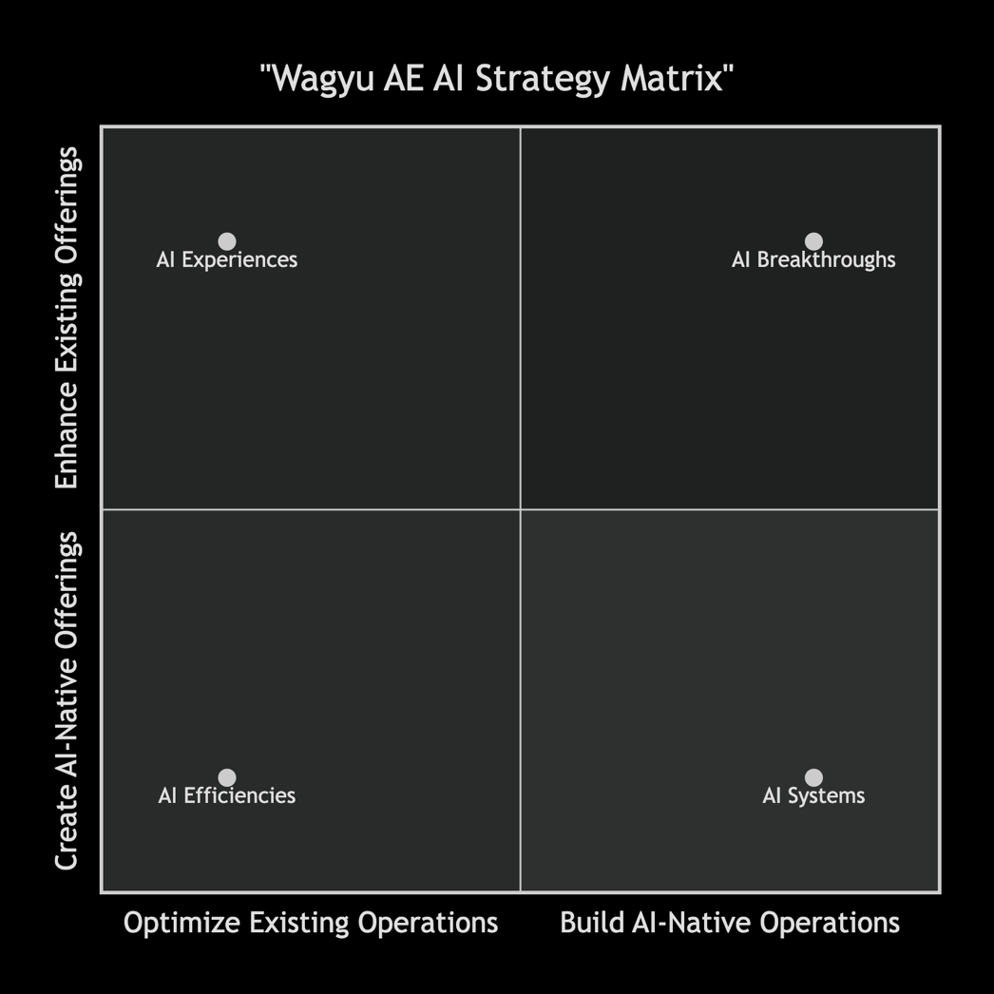

2.2 AI Efficiencies: Optimizing Existing Business with AI
AI Efficiencies focus on applying AI to automate and optimize existing business processes, improving speed, reducing costs, and enhancing decision-making in current operations.
- Supply Chain Optimization: AI can significantly enhance Wagyu AE's supply chain through predictive analytics for demand forecasting, inventory optimization, and logistics planning. Machine learning algorithms can analyze historical sales data, seasonal patterns, and event calendars to predict demand fluctuations, reducing waste and stockouts. For a premium product like Wagyu beef with limited shelf life and high value, such optimization is particularly valuable. Additionally, AI-driven route optimization can enhance delivery efficiency to high-end restaurants and hotels across the UAE.
- Halal Certification Automation: Traditional halal certification relies on manual audits, physical inspections, and paper-based records, which are time-consuming and prone to human error . AI can streamline this process through natural language processing tools that scan supplier contracts, ingredient lists, and processing records to verify compliance automatically. Computer vision systems can monitor production lines in real-time, detecting violations like non-halal products on shared equipment. This automation not only reduces costs but also increases the reliability and consistency of halal assurance.
- Operational Process Automation: Routine administrative tasks such as order processing, invoice generation, and customer communications can be automated using AI-powered systems. Robotic Process Automation (RPA) combined with natural language processing can handle customer inquiries, process orders, and manage documentation with minimal human intervention. This allows Wagyu AE's staff to focus on higher-value activities such as relationship management and strategic planning.
- Quality Control Enhancement: Computer vision and machine learning can enhance quality control processes by automatically assessing Wagyu beef characteristics such as marbling scores, color, and texture. AI systems can be trained to recognize the specific visual attributes of premium Wagyu cuts, ensuring consistency in product grading and identifying potential quality issues before distribution. This application of AI addresses the market's growing emphasis on authenticity and quality verification .

2.3 AI Experiences: Enhancing Customer Experience with AI
AI Experiences leverage AI to create more engaging, personalized, and seamless interactions with customers, transforming how they interact with Wagyu AE's products and services.
- Personalized B2B Recommendations: AI-powered recommendation systems can analyze the preferences, menu patterns, and historical purchases of restaurant and hotel clients to suggest tailored Wagyu cuts and preparation methods. For example, the system might identify that a particular hotel's weekend brunch features Wagyu sliders and automatically recommend specific ground Wagyu blends or portion sizes. This level of personalized service strengthens client relationships and positions Wagyu AE as a strategic partner rather than just a supplier.
- Interactive Culinary Consultation: Virtual AI assistants can provide chefs and culinary professionals with real-time guidance on Wagyu preparation, cooking techniques, and menu integration. These assistants could leverage natural language processing to answer specific questions about different Wagyu grades, marbling characteristics, and optimal cooking methods. For high-net-worth individual customers, a similar AI-powered consultation service could offer personalized cooking recommendations based on their equipment, skill level, and taste preferences.
- Augmented Reality Product Visualization: AR applications could allow chefs and consumers to visualize different Wagyu cuts in various preparation scenarios before purchasing. A restaurant planning a new Wagyu dish could use AR to see how different cuts would appear on their signature plateware, helping with menu planning and presentation design. For direct consumers, an AR app could show how a particular Wagyu steak would look when cooked to different temperatures.
- Enhanced Transparency Interfaces: AI can power interactive transparency dashboards that allow customers to trace the journey of their Wagyu beef from farm to table. By scanning a QR code, chefs and consumers could access detailed information about the specific animal's genetics, feed, halal certification process, and transportation conditions. This application directly addresses the growing consumer demand for supply chain transparency and food provenance information .

2.4 AI Systems: Building AI-Native Operations
AI Systems involve creating fundamentally new operational models where AI drives end-to-end processes, enabling self-optimizing business functions and scalable automation.
- AI-Driven Halal Compliance Ecosystem: Wagyu AE could develop an integrated AI system that monitors halal compliance throughout the entire supply chain in real-time. This system would combine IoT sensors in transportation and storage facilities, computer vision in processing areas, blockchain for immutable record-keeping, and machine learning algorithms for continuous risk assessment. Such a system would provide unprecedented assurance of halal integrity while significantly reducing the manual oversight required. Research indicates that AI can automate the halal certification process, reducing human error and ensuring consistent compliance with halal standards .
- Predictive Supply Chain Network: An AI-native supply chain would proactively manage inventory, logistics, and quality control through predictive analytics and autonomous decision-making. The system could anticipate demand shifts based on factors like hotel occupancy rates, scheduled events in Dubai and Abu Dhabi, and even weather patterns that might affect dining preferences. It could automatically adjust orders from Omi Beef, optimize storage conditions, and schedule deliveries to minimize product handling while ensuring freshness.
- Autonomous Customer Relationship Management: An AI-native CRM system would not just track customer interactions but would autonomously identify opportunities for enhanced service, predict potential issues before they arise, and initiate proactive communications. For example, the system might notice that a restaurant client's Wagyu orders have gradually decreased and automatically schedule a consultation to understand if menu changes, quality concerns, or pricing issues are affecting the relationship.
- Intelligent Quality Assurance Platform: Rather than periodic quality checks, an AI-native system would continuously monitor product quality throughout the supply chain using multiple data streams including temperature sensors, humidity monitors, visual inspection systems, and even spectroscopic analysis where feasible. The system would learn normal quality parameters and immediately flag any deviations, enabling proactive quality management rather than reactive problem-solving.

2.5 AI Breakthroughs: Creating Disruptive AI-Native Products & Services
AI Breakthroughs involve developing entirely new AI-driven offerings that could disrupt the premium protein market and create new revenue streams for Wagyu AE.
- Wagyu DNA Authentication Service: Leveraging advances in genetic analysis and AI, Wagyu AE could develop a service that provides definitive authentication of Wagyu beef genetics and purity. This would address a significant market concern, as the restricted availability of purebred Wagyu cattle and authentic bloodlines outside Japan creates challenges for verifying authenticity . An AI-powered authentication service using genetic markers could provide indisputable proof of Wagyu lineage, creating a new revenue stream while strengthening the brand's credibility.
- Predictive Flavor Profiling System: By analyzing the relationship between Wagyu cattle genetics, feeding practices, environmental factors, and resulting flavor profiles, AI could predict and optimize flavor characteristics. Wagyu AE could offer this as a service to Omi Beef to help optimize their breeding and feeding programs for specific market preferences. For customers, the company could offer "flavor-matched" Wagyu recommendations based on their stated preferences or historical enjoyment patterns.
- Virtual Wagyu Sommelier Platform: Drawing inspiration from wine sommelier services, Wagyu AE could develop an AI-powered platform that pairs specific Wagyu cuts with preparation methods, side dishes, wines, and occasions. This platform could serve both professional chefs designing menus and consumers planning special meals. The system would continuously learn from global culinary trends, customer feedback, and successful pairings to refine its recommendations.
- Sustainable Wagyu Optimization Service: As sustainability becomes increasingly important to consumers and businesses , Wagyu AE could develop AI models that optimize the environmental footprint of Wagyu production and distribution. The service could analyze the entire supply chain to identify opportunities for reducing waste, optimizing transportation efficiency, and minimizing environmental impact while maintaining premium quality. This could become a differentiated service offering for environmentally conscious luxury establishments.
- Hybrid Wagyu Development Platform: With the emergence of lab-cultivated Wagyu fat and hybrid meat products , Wagyu AE could leverage AI to optimize the development of next-generation Wagyu products. AI could model how different genetic combinations, feeding regimens, and processing methods affect the final product's characteristics, accelerating innovation in premium protein development.

3 Step 4: Strategic Prioritization & Execution Plan
3.1 Strategic Priority Framework
Based on the AI Strategy Matrix analysis, Wagyu AE should adopt a phased implementation approach that balances immediate efficiency gains with longer-term transformative initiatives. The prioritization framework should consider implementation complexity, resource requirements, potential business impact, and alignment with the company's core competencies. The following phased approach provides a structured pathway for AI integration:
- Phase 1 (0-6 months): Focus on AI Efficiencies with selected AI Experiences pilots
- Phase 2 (6-18 months): Expand AI Experiences and begin AI Systems development
- Phase 3 (18+ months): Pursue AI Breakthroughs and scale AI Systems
This approach allows Wagyu AE to demonstrate quick wins through efficiency improvements while building the foundational capabilities and organizational readiness for more transformative AI applications. The company's exclusive distribution rights and premium market position provide a stable foundation for gradual but purposeful AI integration.

3.2 Implementation Timeline and Resource Requirements
The successful implementation of Wagyu AE's AI strategy requires careful planning of initiatives across three time horizons, with corresponding resource investments and capability development.
Time Horizon | Strategic Focus | Key Initiatives | Resource Requirements | Success Metrics
Short-term (0-6 months) | AI Efficiencies & Foundation Building | 1. AI-enhanced halal certification automation  2. Predictive inventory management system  3. Customer service chatbot implementation | 1 AI specialist, $50-100K initial investment, external tech partnerships | 20% reduction in certification time, 15% inventory cost reduction, 30% faster customer query resolution
Medium-term (6-18 months) | AI Experiences Expansion & Systems Development | 1. Personalized recommendation engine for B2B clients  2. Blockchain-based traceability platform  3. Computer vision quality control system | Dedicated AI team (3-4 specialists), $200-300K investment, enhanced data infrastructure | 25% increase in cross-selling, 40% improvement in traceability verification time, 50% reduction in quality inspection costs
Long-term (18+ months) | AI Breakthroughs & Full Integration | 1. Wagyu DNA authentication service  2. AI-driven flavor optimization platform  3. Fully integrated AI supply chain ecosystem | Established AI department, $500K+ annual investment, strategic partnerships with tech firms | New revenue streams from authentication services, 30% improvement in customer satisfaction scores, recognition as AI leader in premium food distribution
Table: Wagyu AE AI Implementation Timeline and Resource Requirements

The resource requirements align with industry benchmarks for AI adoption in food businesses, with implementation costs for mid-sized processors estimated at $50,000-$200,000 . Wagyu AE's investment should be viewed as strategic capability building rather than mere cost expenditure, with expected returns including enhanced operational efficiency, strengthened customer relationships, and new revenue opportunities.

3.3 AI Governance and Ethical Considerations
Implementing AI at Wagyu AE requires careful attention to governance and ethical considerations, particularly given the religious and cultural dimensions of halal certification:
- Halal Integrity Preservation: Any AI system used in halal certification must be developed in consultation with Islamic scholars to ensure it respects and upholds religious principles. As noted in research, some Muslim scholars question whether AI can fully replace human oversight in zabiha slaughter, arguing that spiritual intent is human-centric . Wagyu AE should establish a scholarly advisory board to review and approve AI applications in halal assurance processes.
- Data Privacy and Security: AI systems require significant data collection from across the supply chain and customer interactions. Wagyu AE must implement robust data governance policies that protect sensitive business information, supplier details, and customer data. Compliance with international data protection standards will be essential, particularly as the company serves international clients in the UAE's global hospitality sector.
- Algorithmic Transparency: For AI systems making decisions that affect product quality, pricing, or customer service, maintaining transparency in how decisions are made is crucial. This is particularly important for halal certification, where customers need confidence in the certification process. Wagyu AE should implement explainable AI approaches that allow human oversight and understanding of algorithmic decisions.
- Cultural Sensitivity in AI Design: AI systems interacting with customers from diverse cultural backgrounds must be designed with appropriate cultural sensitivity. This includes language considerations, respect for religious practices, and awareness of cultural preferences in business interactions.
- Bias Mitigation: Machine learning systems can inadvertently perpetuate or amplify biases present in training data. Wagyu AE must implement bias testing and mitigation strategies, particularly for systems that make recommendations or decisions affecting customer relationships or product quality assessment.

3.4 Success Measurement Framework
To effectively track the implementation and impact of its AI strategy, Wagyu AE should establish a comprehensive measurement framework encompassing efficiency metrics, customer experience indicators, innovation outcomes, and financial performance:
- Operational Efficiency KPIs:
  - Reduction in halal certification processing time (target: 40% reduction within 12 months)
  - Inventory carrying cost reduction (target: 20% reduction within 18 months)
  - Supply chain visibility improvement (target: real-time tracking of 100% of shipments)
- Customer Experience Metrics:
  - Net Promoter Score improvement among B2B clients (target: 15-point increase within 24 months)
  - Customer engagement with AI-powered services (target: 60% of clients using AI recommendations within 18 months)
  - Transparency satisfaction scores (target: 90% of clients rating traceability as "excellent")
- Innovation and Growth Indicators:
  - Revenue from new AI-enabled services (target: 15% of total revenue within 36 months)
  - Recognition as innovation leader (target: industry awards or features in premium culinary publications)
  - Technology adoption rate (target: 80% of target customers using at least one AI service)
- Halal Assurance Metrics:
  - Certification accuracy (target: 99.9% accuracy in halal compliance verification)
  - Audit efficiency (target: 50% reduction in manual audit hours)
  - Consumer trust indicators (target: 95% positive ratings for halal assurance)
These metrics should be tracked through a balanced scorecard approach that provides regular visibility into AI implementation progress and business impact. Regular reviews (quarterly in early stages, transitioning to biannually as systems mature) will allow for course correction and optimization of the AI strategy.

4 Conclusion and Strategic Recommendations
4.1 Summary of Strategic Positioning
Wagyu AE occupies a privileged but vulnerable position in the UAE's premium protein market. The company's exclusive distribution rights for Omi Beef's halal Wagyu provide a strong foundation, but traditional business models face increasing pressure from technological disruption, changing consumer expectations, and evolving market dynamics. The AI Strategy Matrix analysis reveals significant opportunities across all four quadrants, with particular promise in leveraging AI to strengthen halal assurance, enhance customer relationships, and build more responsive operations.
The global Wagyu beef market's projected growth to USD 8.93 billion by 2032 , combined with increasing demand for transparent, authentic, and premium food experiences, creates a favorable environment for Wagyu AE's AI transformation. By strategically implementing AI across its business, the company can evolve from a traditional distributor to a technology-enabled culinary partner, creating new value for both suppliers and customers while strengthening its market position.

4.2 Path Forward and Immediate Next Steps
To initiate its AI transformation journey, Wagyu AE should take the following immediate actions:
- Establish an AI Transformation Team: Form a cross-functional team with representatives from operations, customer service, technology, and halal certification to lead the AI strategy implementation. This team should include both internal stakeholders and external AI specialists.
- Conduct a Data Readiness Assessment: Evaluate current data collection, management, and infrastructure capabilities to identify gaps that must be addressed to support AI implementation. This assessment should include both operational data (supply chain, inventory, certification) and customer data (preferences, orders, feedback).
- Develop Pilot Project Roadmap: Identify 2-3 high-impact, manageable AI pilot projects from the Phase 1 initiatives, focusing on areas with clear business value and relatively straightforward implementation. Potential pilot projects could include an AI-enhanced halal documentation system or a predictive inventory tool for key restaurant clients.
- Establish Governance Framework: Create initial AI governance policies addressing data privacy, algorithmic transparency, and halal integrity preservation. Begin consultations with Islamic scholars regarding appropriate AI applications in halal assurance.
- Explore Strategic Partnerships: Identify potential technology partners with expertise in food supply chain AI, blockchain traceability, or computer vision quality control. Consider partnerships with UAE-based AI firms or institutions to leverage local expertise and potentially access government innovation initiatives.
By taking these initial steps, Wagyu AE can begin its transformation into an AI-enabled market leader in premium halal protein distribution, building capabilities that will support sustained growth and competitive advantage in the evolving luxury food market of the UAE and beyond.

